2017 SEAGA Conference Jakarta
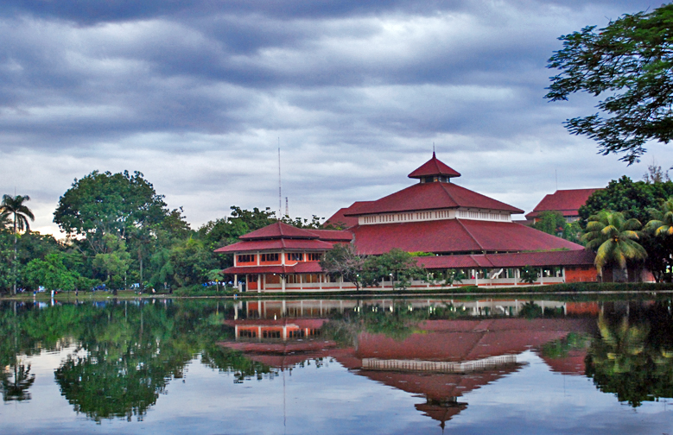

Proposal for 6 Days 5 Nights SEAGA Conference
The cost and proposed programme for the 6 Days 5 Nights SEAGA Conference based on a minimum of 20 participants is as below.
DATE | PROPOSED ITINERARY
Day 1  27 November  (Dinner) | SINGAPORE – JAKARTA-DEPOK  - Meet and assemble at Changi Airport  - Upon arrival at Jakarta, be greeted by our friendly guide and proceed to Depok for hotel check in.  - Welcome Dinner.  - Dinner and check into your hotel.  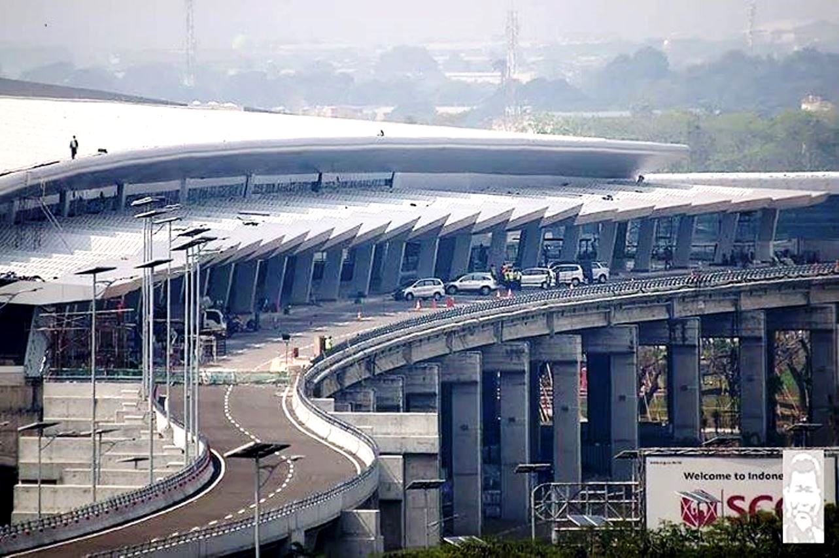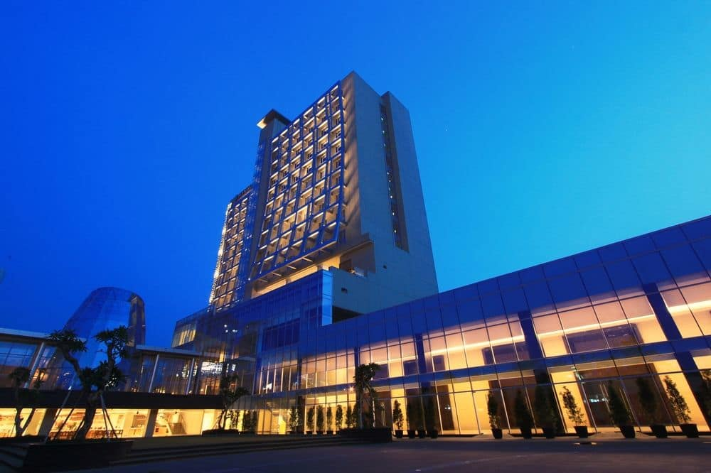
Day 2-3  28 November/29 November  (Breakfast Only) | DEPOK  - Breakfast at hotel  - Full day conference at Universitas Indonesia Depok. The University is within walking distance to the hotel which is a 9 minutes’ walk away.  - Return to hotel  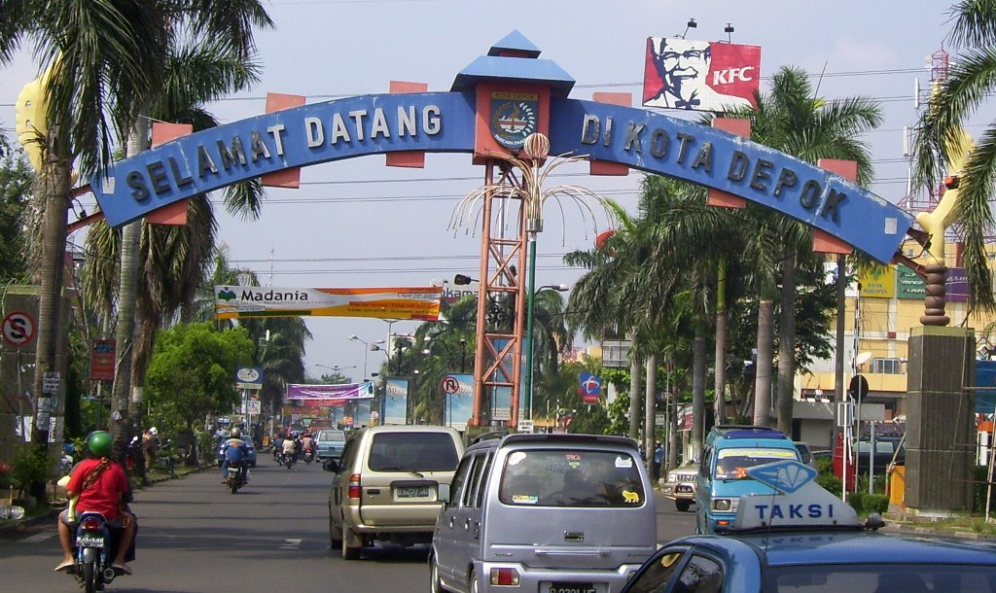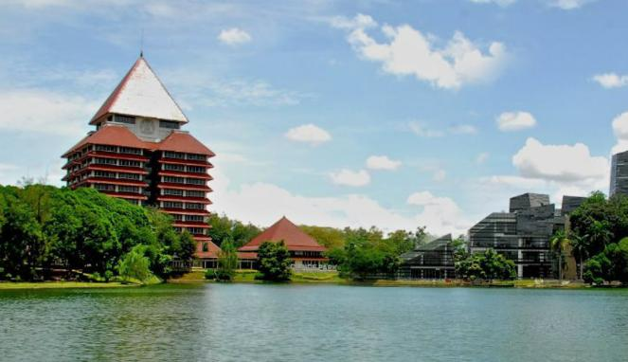
Day 4  30 November  (Breakfast/Lunch/Dinner) | DEPOK  - Breakfast at hotel  - Proceed to Puncak area for geographical studies at Cibeureum Waterfall on the slope of Mount Gedhe Pangrango [Physical Geography]  - The participants will be divided into two groups. The first group will investigate the supporting amenities and site attractions of the waterfall and this will involve trekking. The second group will investigate the site attractions of the marketplace and botanical gardens at the foot of Mount Gedge Pangrano. [Effects of Tourism]  - Lunch at local restaurant  - Proceed to Gunung Mas Tea Plantation. Now a government owned estate, the Gunung Mas tea plantation was cultivated in the Dutch colonial era. The site is sprawled out over more than 6,000 acres, where row after row of tea grows in cool climates of between 18 and 25°C. Delegates will be able to get a glimpse into the drying, processing and packaging of the tea grown at the plantation. [Human Geography]  - Dinner at local restaurant and return to your hotel.  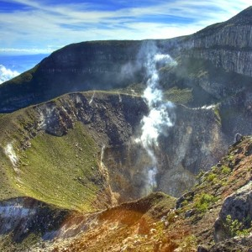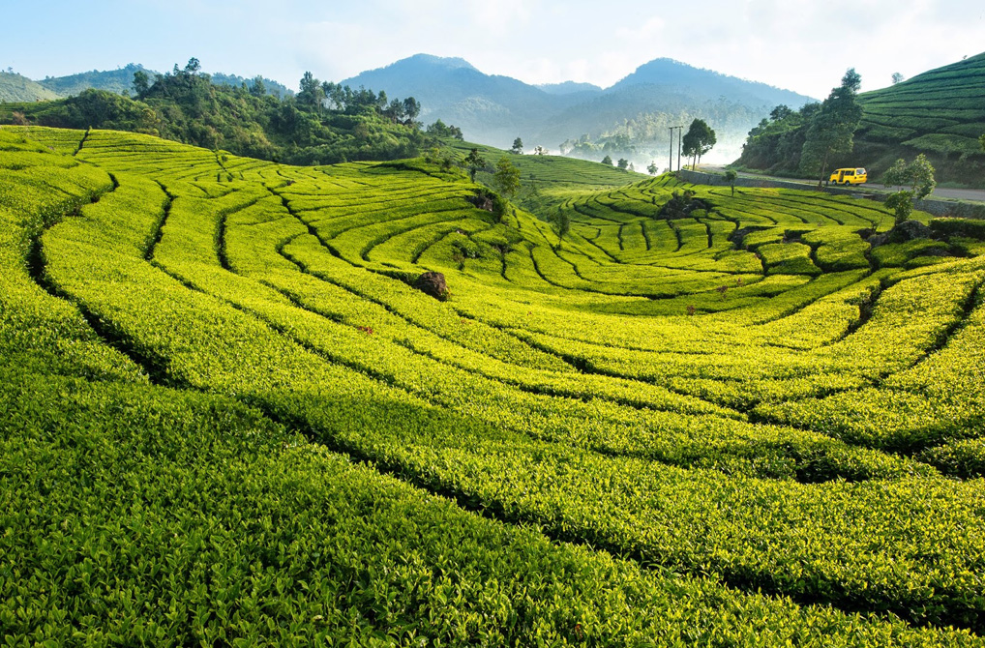
Day 5  1 December  (Breakfast Only) | DEPOK-JAKARTA-SINGAPORE  - Breakfast at hotel  - Full day conference at Universitas Indonesia Depok. The University is within walking distance to the hotel which is a 9 minutes’ walk away.  - Return to hotel
Day 6  2 December  (Breakfast Only) | DEPOK-JAKARTA-SINGAPORE  - Breakfast at hotel  - Jakarta city immersion  - Depart for airport  - Arrived at Singapore

Proposed Flight Schedules:
Singapore Airlines (SQ) - Jakarta:

Singapore-Jakarta SQ960 27 Nov 2017 1515-1600
Jakarta-Singapore SQ959 2 Dec 2017 1410-1700

The above flight schedule is correct at the date of printing but is subjected to changes with or without prior notice.

Cost of 6 Days 5 Nights SEAGA Conference per delegate

Services | Twin | Triple | Single
Cost of Land Arrangements | $465.00 | $476.00 | $631.00
Group Airfare [Singapore to Jakarta] | $280.00 | $280.00 | $280.00
Airport tax & fuel surcharge | $55.00 | $55.00 | $55.00
Service of Singapore Tour Manager | $70.00 | $70.00 | $70.00
Conference Fees [USD 250] | $345.00 | $345.00 | $345.00
NTUC Income Insurance [Superior + Option B] | $36.00 | $36.00 | $36.00
Total Cost | $1,251.00 | $1,262.00 | $1,417.00

Quoted Tour Fare Includes:

- Airfare as indicated. fuel and government taxes subjected to changes
- 5 nights’ accommodation in hotel indicated above
- Meals as indicated in itinerary above
- Admissions and entrances as per itinerary.
- Coach usage as indicated in itinerary.
- Service of one STA Travel Tour Manager throughout the trip
- Service of one local guide for Day 4
- Tipping for coach driver and tour guide.
- NTUC Income Superior Option B
- Conference Fees

Quoted Tour Fare Excludes:
- Passport, visa and documentation charges where applicable.
- Any optional tours mentioned in the itinerary.
- All items of personal nature such as drinks, laundry, room service, etc.
- Surcharges due to peak season, holidays, etc.
- Increase in airport taxes/fuel surcharges (subject to change until ticket issuance).

HOTEL MARGO DEPOK

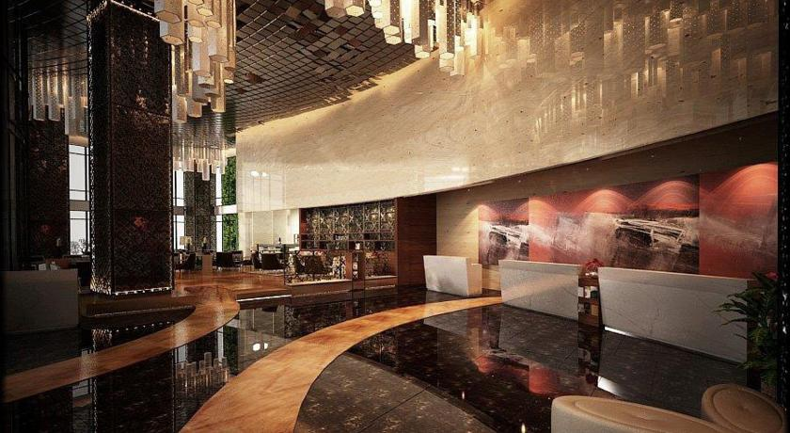

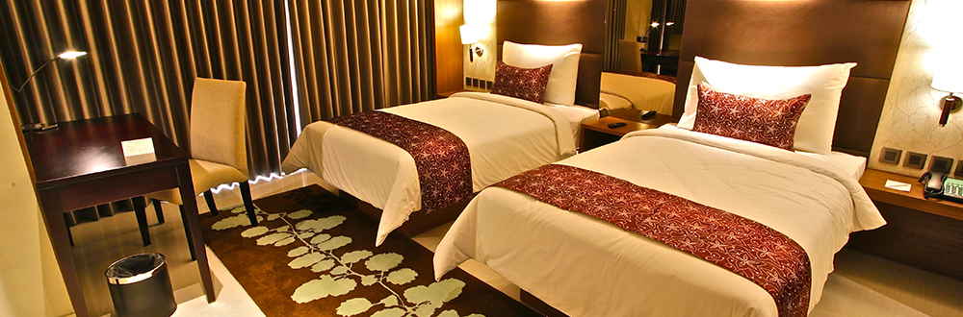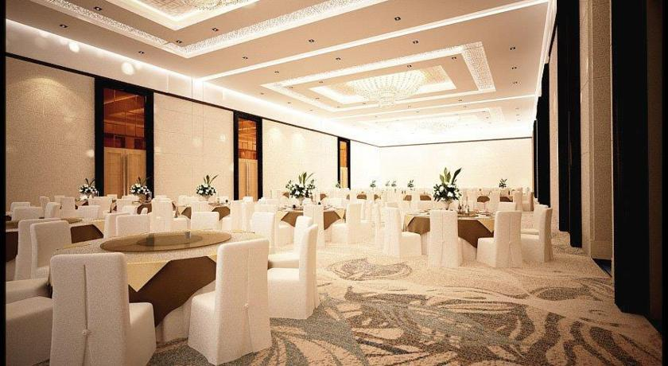

From the hotel website [http://themargohotel.com/]
The MARGO Hotel located on Margonda Street Depok is Southern Jakarta’s premier choice for business travellers on short and long term assignments and the very best meetings and events location in the area. The hotel is strategically closed to South Jakarta business district TB. Simatupang, Jl. Raya Bogor, University of Indonesia and Depok Residential area. The hotel is side by side with MARGOCITY Mall, the biggest shopping centre in Depok for guests to fulfil their shopping needs. The MARGO Hotel is the first 4*+ hotel in Depok, offering unique chic and modern minimalist concept which combines natural elements. Another uniqueness is "The Old House" the cultural heritage from Dutch era which become the icon of the hotel complex. The MARGO Hotel offers 285 spacious guest rooms and suites, 11 meeting rooms and a Grand Ballroom for up to 1200 persons, complemented by a wide range of conveniences including an All Day Dining Restaurant, Executive Lounge, Lobby Lounge, recreational facilities such as swimming pool with Café and a well-equipped gym.

TERMS & CONDITIONS FOR 6 DAYS 5 NIGHTS CONFERENCE
The following terms and conditions govern the purchase of the travel arrangements through STA Travel for your groups and form part of your agreement with us.

- Appointment of STA Travel
Once Gebiz closes, and upon receiving confirmation of the appointment of STA Travel from the school in writing, STA Travel will proceed to work on the operations required for the trip (reservation of flight seats, hotels, coach and school visits). Due to certain time constraints, this may take place before or after the Purchase Order is issued. Such arrangements will be highlighted to the school in writing.

- Deposits
Upon your appointment, a non-refundable deposit of 30% of the total tour fare should be lodged with STA Travel immediately. STA Travel does not guarantee that flight seats and hotels are confirmed for the group at this point.

- Balance Payment
The balance payment will be billed to the school upon the group’s return from the trip and schools are liable to make payment in full within 30 days. Any refunds will be granted separately and should not be deducted from this invoiced amount. STA Travel reserves the right to impose a late payment fee of 1% of the amount outstanding beyond the credit term of 30 days dated on the invoice.

- Cancellation of Tour
Cancellation of school tour must be made in writing and it shall be effective from the date of receiving the notice.
The following cancellation charges will apply:
Administration Fee - $50.00
Deposit - Non-refundable
30 to 45 days before departure - 40% of tour fare
16 - 29 days before departure - 70% of tour fare
Within 15 days from departure - 100% of tour fare
Airline cancellation charges - As imposed by the airline at the point of
receiving cancellation notice
Hotel and land arrangements - As incurred at the point of receiving the
cancellation notice

In the event that STA Travel has made payment to external suppliers larger than the sum of cancellation mentioned above, the school is responsible for the full sum plus STA Travel administrative charges of $50.00

- Refunds
In the event that a passenger in the group cancels due to compassionate reasons, STA Travel may, as a gesture of goodwill, assist in processing a refund for any unutilized portion. The amount of refund however is subject to the airline’s or supplier’s confirmation and passenger is expected to assist with the relevant documentation required. STA Travel agreeing to assist with the refund process does not mean that the ticket is refundable. The refund process may take up to 6 months.

- Meals Arrangements
Halal Meals: Halal meals will be provided for passengers who request for them wherever possible during the trip. In the event that this is not possible, vegetarian and seafood options will be made available. We seek the understanding of the teachers and school that in many locations restaurants options are limited for groups. We will however, be able to request for Halal meals on board the flights.

Refund of meals: In the event that meals are hosted by companies or school partners; or when the students are at location with many meals options when it will be more convenient to refund than to gather them for a meal, STA Travel may refund the students in cash the amount budgeted for the meal(s) concerned. This will be specified in our quotation or will be done only after discussion and upon receiving approval by teachers and/or school.

- Suspension or Termination of Trip due to Abnormal Circumstances
In the event of any abnormal circumstances that affect the public health, safety and good order of the country or countries of visit, the school may opt to suspend or terminate the contract by providing STA Travel with a written notice received at least 7 days before departure. The school is liable for any amount paid or committed by STA Travel to suppliers concerned on behalf of the group to this point. STA Travel will impose a handling fee of $50 per person as administrative and cancellation fee.

STA Travel is committed to MOE and the school to minimize the costs incurred by the school as a result of such termination. A full waiver of the cancellation charges is at the supplier’s discretion and is affected by the travel advisory available and/or any supporting documents from relevant authority or authorities. Note: Abnormal circumstances may include, but not limited, to (H1N1) Influenza, terrorism, industrial strife.

- Reduction in Group Size
Where the group size falls below the minimum number stipulated in the quotation, STA Travel reserve the right to increase the tour fare quoted accordingly.

- Visas and Travel Documents
STA Travel will assist to provide advice on the visa requirements for the country(s) of travel based on the passport information provided and raised by the passengers and/or organizing staff. Any information given by STA Travel is correct at the point that it is given and may be subject to change without prior notice.

- Airport Tax & Fuel Surcharges
Airport taxes and fuel surcharges are subject to change without prior notice. Fuel surcharges can only be confirmed at the point of ticket issuance. Any increase in the taxes and surcharges from the current rate will be borne by the passengers.

- Increase in Land Costs
Given the drastic rise and unpredictable nature of fuel costs, coach prices and land tours are subject to a surcharge, to be borne by the passengers, in the event of a drastic increase in fuel costs.

STA Travel acts only in the capacity of Agents for the operators in all matters of transportation, tour, accommodation and other services. STA Travel cannot accept any liability or responsibility for any alteration, delay or cancellation caused by war or threat of war, civil strife, natural disaster, terrorism, industrial disputes, fire, bad weather, sickness, act of government or public authorities, events beyond the control of STA Travel or other circumstances amounting to force majeur and/or Acts of God.

